Step for establish web server using AWS (EC2)

* Log on to the AWS console
* Go to the services to compute EC2
* Go to the instance and Launch Instance
* Now we will fill the details like
* Instance name
* Key pair
* A key file will downloaded.
* Keep in mind all setting as it is then on Launch.
* Instance in right panel of the window.

Instance will be created

Go to the instance , pick your instance then click on connect.

* You will forward to join your instance
* Select RDP client and download remote desktop file then known your password.
* Transfer private key file and select that key pair file to your password.
* Copy your password.
* Open remote desktop file and enter your copy password.

Now your Virtual Machine is open…

* Then off your window defender

Then, download the Apache server from web browser @ Apache VS17 binaries and modules download(apachelounge.com)

and put your server file in C drive

Now we have to open httpd file from bin inside Apache24 i . e C:\Apache24\bin.

* Now open your CMD and put your address to your bin file by command. 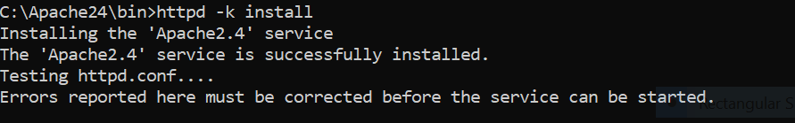

Now server is installed.

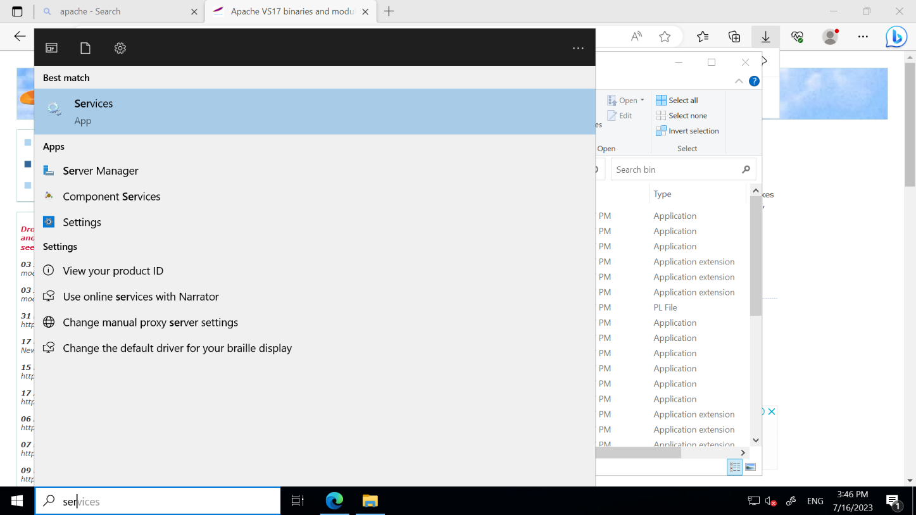

* Open server.

Now we will start Apache server.

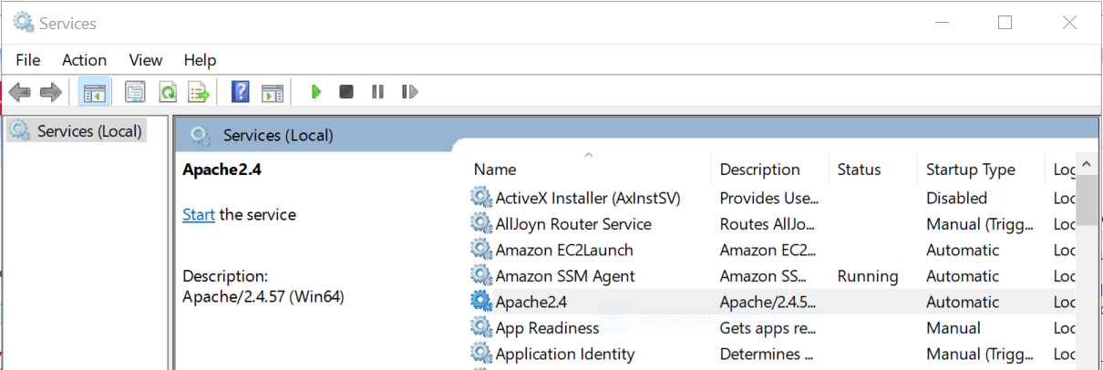

* Now open browser and enter 127.0.1

